**📘 Pocket Planner Management System**

**🔧 Tech Used:**

* HTML
* CSS
* Bootstrap
* JavaScript (with localStorage)

**✅ 1. Signup Page**

* Form: Username, Email, Password
* Store user info in localStorage
* Redirect to Login page

**✅ 2. Login + OTP Verification**

* Step 1: User enters email/password
* Step 2: If valid, generate OTP (simulate via alert)
* Step 3: OTP Input → Verify → Show Dashboard

**✅ 3. Dashboard (Add & View Entries)**

Each entry contains:

* Title
* Amount
* Category
* Date
* Description

Features:

* Display entries in a table on the same page
* Options to Edit and Delete
* Use localStorage to save and retrieve entries

**✅ 4. Reports**

* **Filter Options**:
  + From Date → To Date
  + From Date → To Date + Category
* **Charts**:
  + Use Chart.js to generate pie/bar chart of expenses
  + Based on amount per category or date range

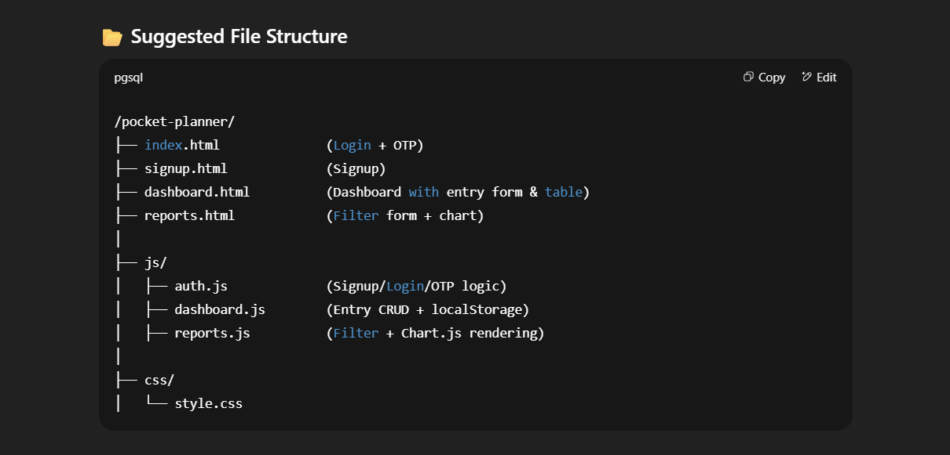

**🔹 1. Signup Page**

**Fields:**

* 👤 **Username**
* 📧 **Email**
* 🔑 **Password**

**🔹 2. Login + OTP Page**

**Fields:**

* 📧 **Email**
* 🔑 **Password**
* 🔢 **OTP** (after password verification – simulate with alert)

**🔹 3. Dashboard (Transaction Entry Form)**

**Fields:**

* 📝 **Title** – खर्चाचे नाव (उदा. Grocery, Rent)
* 💰 **Amount** – किती खर्च झाला
* 🗂️ **Category** – खर्चाची category (उदा. Food, Travel, Bills)
* 📅 **Date** – खर्च झालेली तारीख
* 🧾 **Description** – थोडकं description (optional)

✅ याच पेजवर data display होईल, Edit आणि Delete ऑप्शनसह.

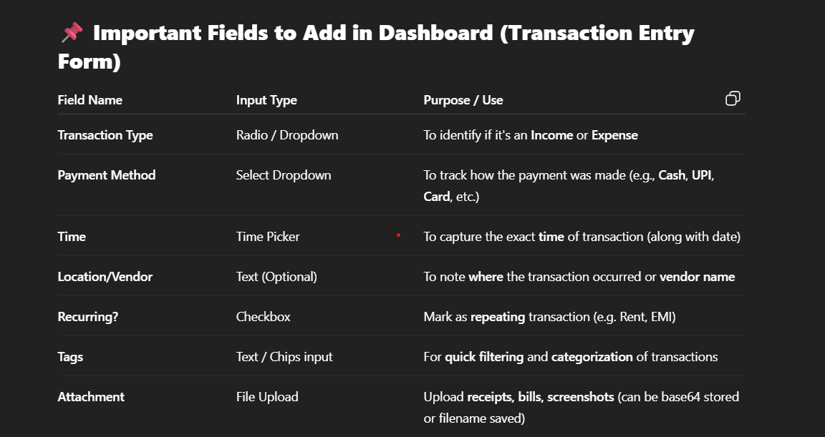

**🔹 4. Reports Page**

**Filter Fields:**

* 📅 **From Date**
* 📅 **To Date**
* 🗂️ **Category** (optional)

📊 Filter नुसार charts पण दिसतील (Chart.js वापरून).